
TEST – ATOMIC STRUCTURE, PERIODIC TABLE
AND CALCULATIONS

NAME: __________________ DATE: _______ Mark: _______/40

TASK: You will have at most 50 minutes to answer all questions within this test. Show your choice by crossing your selection.

Part one - Multiple Choice

1. Electrons are thought to be located in distinct energy levels or shells in an atom.
The maximum number of electrons which can be found in the third (n=3) shell of an atom is:

a) 36
b) 18
c) 8
d) 2

2. The type(s) of orbitals found in the third shell (principal energy level three) are:

a) s orbitals only.
b) s and p orbitals.
c) s, p and d orbitals.
d) s, p and f orbitals.

3. How many ‘d’ orbitals are to be found in any given shell?

a) 2
b) 3
c) 4
d) 5

4. An element has the following ground state electron configuration:

1s² 2s² 2p⁵

How many ‘valence’ electrons does this atom have?

a) 1
b) 2
c) 5
d) 7
5. The ground state electron configuration for Magnesium is

a) 1s² 2s² 2p⁶ 3s²
b) 1s² 2s² 2p⁶
c) 1s² 2s² 2p² 3s² 3p² 4s²
d) 1s² 2s² 2p

6. An element has the following ground state electron configuration:

1s² 2s² 2p⁶ 3s² 3p⁵

Based on this information, the element would most likely belong to which group in the periodic table?

a) Group I.
b) Group IV.
c) Group VII.
d) Group VIII.

7. The electron configuration: 1s² 2s² 2p⁶ 3s² 3p⁶ could be that of all of the following, with the exception of

a) Ca²⁺
b) Kr
c) S²⁻
d) Cl⁻

8. Which of the following pieces of equipment would NOT be used in a typical acid-base titration:

a) conical flask
b) Florentine flask
c) pipette
d) beaker

9. A primary standard is prepared using a chemical which:

- has a known formula and is obtainable in a pure form.
- is not hygroscopic
- is a base with a carbonate anion.
- must have a relatively high formula mass.

The statements which typify a primary standard are:

a) iv only
b) i, iii and iv.
c) i, ii and iii.
d) i, ii and iv.
10. Deliquescent describes a chemical which:

- has a tendency to attract contaminents from the air.
- absorbs water vapour from the air and dissolves in it, forming a concentrated solution.
- can absorb up to 70% of its own mass of water vapour and becomes damp but does not dissolve.
- is resistant to attracting/absorbing water from the atmosphere resulting in a reliable primary standard.

11. The graph below is a plot of pH against volume of titrate for a typical titration.

By studying the graph, it can be seen that the titration involves:

a) a weak acid added a strong base.
b) a strong base added to a strong acid.
c) a strong acid added to a strong base .
d) a strong acid added to a weak base.

12. ‘Ionisation energy’ refers to

a) the amount of energy required to form a positive or negative ion.
b) the amount of energy required to add an electron to an atom in the gaseous phase.
c) the amount of energy required to remove the most loosely bound electron from an atom in the gaseous phase.
d) the amount of energy released when a positive or negative ion is formed.

The next two questions refer to the following graph, which shows the ionisation energies of the first 20 elements.

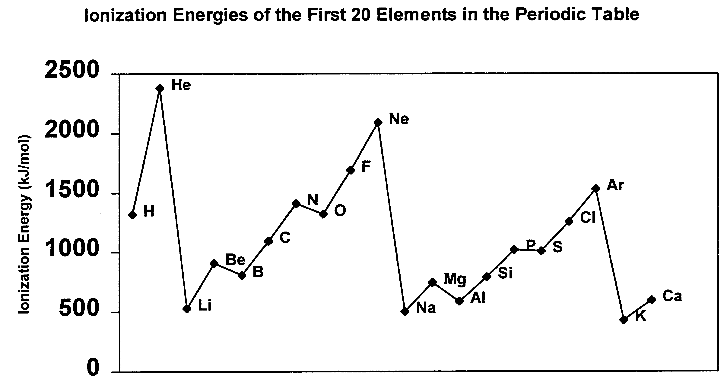

13. Which one of the following best accounts for the general increase in ionisation energy across a row of the periodic table?

a) The decreasing distance between the nucleus and the outer electrons in the atoms of the elements across a row.
b) The increasing nuclear charge within the atoms of the elements across a row.
c) The increasing number of electrons in the atoms of the elements across a row.
d) The increasing number of neutrons in the atoms of the elements across a row.

14. Which one of the following statements is FALSE?

a) Elements that have few valence electrons tend to have low ionisation energies.
b) Inert gases all have high ionisation energies.
c) Generally, as the number of valence electrons increases across a row in the periodic table, so too does ionisation energy.
d) It reqires more energy to remove an electron from a p orbital than from an s orbital, as illustrated by the ionisation energies of magnesium and aluminium.

15. Moving down the periodic table, you would expect to see

a) a decrease in the atomic radius.
b) a decrease in the melting and boiling points.
c) an increase in the metallic nature of elements.
d) first an increase then a decrease in the ionization energies

END OF PART ONE

Part Two – Short Answer

Instructions: Answer all questions on the answer sheet provided.

1. The first eight successive ionisation energies (in kJ mol⁻¹) for an element are:
1.02 1.91 2.92 4.96 6.28 21.3 25.4 29.8

- Why is there an increase in the ionisation energies of this element?
____________________________________________________________________________________________________________________________________________________________________________________________________________________________________________________________
1 mark
- How many valence electrons are present in this element?
_______________________________________________________________
1 mark

- Explain why there is a large increase in the 5th and 6th ionisation energies of this element.
____________________________________________________________________________________________________________________________________________________________________________________________________________________________________________________________
1 mark

- Element X has the outer electron configuration of s²p³.
- Write the formula of the hydride of X.
___________________
- What monatomic ion would X be likely to form?
___________________
2 marks

3. Given below are randomly arranged first ionisation energies in kJ mol⁻¹ of the elements: carbon, fluorine sodium, caesium and magnesium. Write down each of these ionisation energies with its matching element alongside.

- 1 681 ______________
- 376 ______________
- 738 ______________
- 496 ______________
- 1086 ______________
5 marks
4. Write the electronic configuration for:
- Argon _______________________
- Calcium ion _______________________
2 marks
5. In a typical titration, a base is placed in the burette and an acid placed in the conical flask. An indicator is then added to find the end point.

Indicator Name pH

Bromophenol Blue 3.0-4.6
Methyl Red 4.4-6.2
Phenolphthalein 8.3-10.0

a) From the list of indicators above, which would be used if the acid was HCl and
the base was Na₂CO₃.

___________________ 1 mark
b)Sketch a graph showing pH versus volume for the titration.

2 marks
END of PART TWO

Part Three - Calculations

Q.1) An unknown organic compound X contains only the elements carbon, hydrogen and oxygen. When 1.360 g of X is completely burnt in an excess of oxygen the products are found to be 1.113 g of water and 1.384 L of carbon dioxide measured at a temperature of 273 K and a pressure of 101.3 kPa.

When a further 2.500 g sample of X is vaporised the volume of the vapour produced is found to be 868.9 mL when measured at a temperature of 373 K and a pressure of 101.3 kPa.

  - Determine the empirical formula of X.
  - Determine the molecular formula of X.

_____________________________________________________________________________________________________________________________________________________________________________________________________________________________________________________________________________________________________________________________________________________________________________________________________________________________________________________________________________________________________________________________________________________________________________________________________________________________________________________________________________________________________________________________________________________________________________________________________________________________________________________________________________________________________________________________________________________________________________________________________________________________________________________________________________________________________________________________________________________________________________________________________________________ 6 marks

Q.2) A sample of aluminium carbide, Al₄C₃ is added to a dilute acid solution. The following reaction goes to completion:

Al₄C_{3 (s)} + HCl _{(aq)} AlCl_{3 (aq)} + CH_{4 (g)}
Balance the equation. 1 mark

In one particular experiment the methane produced was collected and found to have a mass of 1.754 g . What mass of Al₄C₃ was added to the acid solution?

____________________________________________________________________________________________________________________________________________________________________________________________________________________________________________________________________________________
____________________________________________________________________________________________________________________________________________________________________________________________________________________________________________________________________________________
3 marks

END OF PART THREE
END OF TEST

